ACSim Version 1.0

Introduction
Over the past several years, virtual traffic volume has grown tremendously however it’s still very scattered, random and unreliable. To practice ATC efficiently there’s no replacement for controlling under the critique of a knowledgeable mentor or instructor, so the members of VATSIM’s Boston ARTCC have come up with the idea of having a program simulate traffic. To implement that idea, we have come up with the ACSim.
The ACSim is a client-side tool that connects to an FSD© server and initializes aircraft situations setup in custom made flight files. Each file provides a different amount, type and arrangement of traffic ranging from a few VFR flights to an “n” number string of IFR and VFR mixed aircraft of any type. Each aircraft connects to the server via its own socket all controlled via user inputs through the ACSim.
With the introduction of the ACSim, instructors and mentors can train or test their students at any time that is convenient: No longer will we have to wait for a busy night to administer and over-the-shoulder. In addition, we feel that students will learn to handle large volumes of traffic with much more efficiency after using the ACSim with a mentor on a regular basis because it develops the most important skills of a constant scan of all aircraft in a controllers sector, planning ahead and learning to get the “big picture.”

New Features
New Additions to Version 1.0
- Ability to add aircraft on the fly
- Graphic interface to create situation files
- New Flight file format
- Aircraft can now fly to ndb’s, fixes and airports
- Server Ports can be changed
- Windows INI file is created to save last settings
- ACSim now parses all of its data from sector files
- Aircraft squawk can be changed by the user
Changes to Version 0.4.1
- Pause Feature Fixed
- Error Dialogs Added
- Multiple Locations Allowed
- Location added to title bar
- Each Field Auto Selects now
- Improved Performance
- You can now type a letter in the aircraft choice menu and it’ll select the first aircraft with that letter
- Fixed the departure Climb rate problem
- Added Dialog Popups on quits and disconnects.
New Additions to Version 0.4
- All aircraft can be paused
- Aircraft Situations can be loaded as a file
- IP Address, userid and password are variable
- Aircraft can Ident
- Aircraft can navigate to any VOR
- Aircraft can fly an ILS
- Departures are now possible
- Aircraft can be deleted individually
- Aircraft can simulate a landing

System Requirements
This program has only been tested on Windows 98, ME, 2000 & XP however Windows 95 should also be compatible. Winsock Version 2.0 is required as well as an internet connection.

Getting Started For the First Time
Startup the ACSim and goto Settings>Connection Settings.

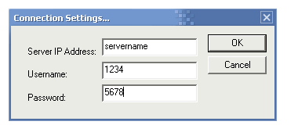
Figure 1. ACSim Connection Settings.

This is where you type in the IP address to the server as well as your CID and Password. Note: Data will be automatically saved on exit.

New Aircraft
This allows you to add a new aircraft to the server and to your control “on-the-fly.” It does not save the aircraft in any situation file for future use. It’s a one shot deal. When you first click on it, you’ll be presented with a dialog similar to that in Figure 2 below.
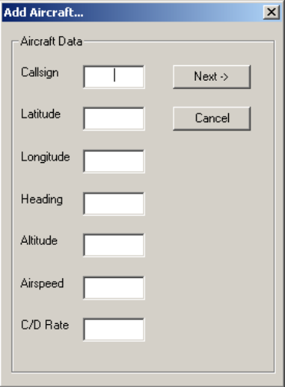
Figure 2. Add Aircraft Screen 1

Every item on this screen is a requirement. You must fill in all fields or you will not be able to continue to the next screen. When they are filled in, click “Next” and it will take you to the screen shown in Figure 3.

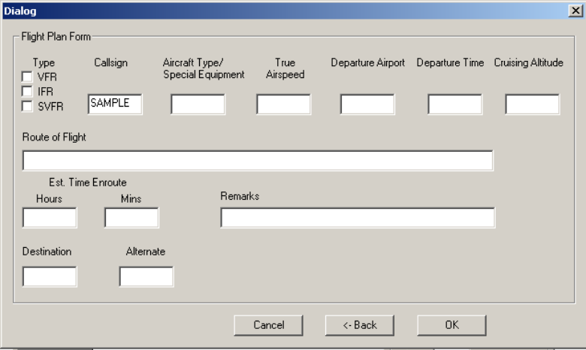
Figure 3. Add Aircraft Screen 2

On this screen, everything is optional. Fill in as much or as little data as you care about. Any field left blank will be left blank on the aircraft’s flight plan and it will automatically be created as a VFR aircraft. Choosing cancel will erase all input, choosing back will take you to the previous screen and allow you to make changes. Choosing OK will put the aircraft on the server (careful of making duplicate callsigns!) and it will pause itself and all old aircraft.

New Situation File
Situation files are the .acs files that you load to put a scenario on the server. To create these files, choose this is the menu option to choose. The screens look and work the same as the New Aircraft screens. The first dialog is all required data while the second is all optional data. Hitting next will bring you back to the first screen to enter data for the next aircraft. Keep hitting next until you have created the number of aircraft that you desire, then hit “Done.” You will be prompted to chose a filename and folder to save the new situation. After that you can load it up at anytime!

Open Sector File
This allows the user to pick a sector file from which ACSim will get it’s data. I suggest using the same sector file that your student is controlling with, or something with similar data. When I doubt use a Center sector file because they have the most data for your area. You MUST open a sector file before you can create, or open any aircraft or situation files.

Open Aircraft File
This allows the user to pick one or more aircraft situation files to load into the ACSim. You must have already loaded a sector file or this option is disabled.

Close Sector File…
If you plan on changing sector files to train at a different airport or location, you must first close the old sector file. You can do so by clicking on this menu option.

Now that you understand the menu choices, let’s take a look at the user input screen (Figure 4.) This is where the mentor/instructor has access to each aircraft. You will notice that each field is disabled (ghosted) until an aircraft situation has been loaded or you have created an aircraft. Each field is based on the aircraft that is selected from the “Aircraft Selector” drop down box. When an aircraft is selected from there, the rest of the boxes will show the last command that the aircraft was given. For example if you told “N922MB” to climb to 12,000 feet, you will see “12000” in the Altitude field. In other words, it does not necessarily show the current position, altitude or airspeed of the aircraft, it merely shows the aircraft’s goal; that is what it’s trying to do. Each field will be discussed in more detail now.

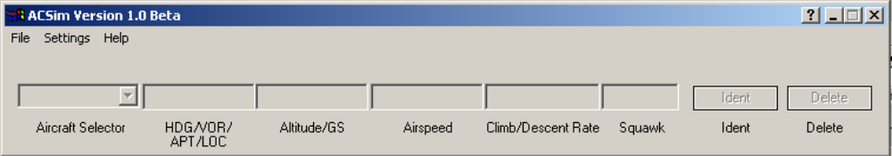
Figure 4. ACSim user input screen.

Aircraft Selector(select) – This field contains the drop down box that the user selects the aircraft that he/she would like to control. Upon selecting an aircraft, the rest of the the fields will display the last commands given to that aircraft. Only one aircraft may be selected at a time. See Figure 5.

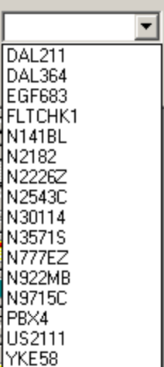
Figure 5. ACSim Aircraft Selector Dialog

Heading/Vor(###/ABC/4R) – This field serves as the “NAV” control of the aircraft. Any valid heading from 001 – 360 may be entered. North should be entered as 360 and not 000. Also note that 3 digit headings are NOT required. A heading of “010” may simply be entered as “10,” however it is a good practice to use a 3 digit heading. You will find out why later. When you select an aircraft the selector box, there will already be a heading in this field. To enter a new one, just click into the field and it should highlight itself. Then you can type over the old data. Also using “TAB” to change fields is possible and suggested. You’ll notice that pressing “ENTER” in one field will automatically bring you to the next field. Once a heading has been entered in this field, press “ENTER” and immediately the aircraft will begin turning in the best direction to achieve that heading. If you desire an aircraft to turn in a direction that would be longer, for instance turning from 360 to 040 by turning LEFT, you must type intermediate headings until the aircraft is at a heading in which a LEFT hand turn would be the shortest. Each aircraft turns at Standard rate. Remember that the radius of a standard rate turn is dependant on airspeed. In addition to giving an aircraft a heading, this field serves two other purposes. First, you may also type in any VOR, NDB, Fix or Airport identifier found in your airspace. You MUST use the 3 letter identifier for NDB’s/Vor’s and the 4 letter ICAO names for airports. When you type in the identifier and press “ENTER,” the aircraft will immediately calculate the shortest turn required to go to that navaid and it will track to the navaid on it’s own without any further input. Once an aircraft reaches the navaid, if no further commands are given it will continue turning to reach the navaid so it will basically remain in close proximity to the navaid. Note: This depends on the aircraft’s airspeed. The last and maybe the most interesting feature of this field is its use to track a localizer. Any aircraft can fly any localizer at any airport that has one. All that is necessary is the runway number. If you would like the aircraft to fly the rwy 4R localizer, merely type “4R” in this field and press enter. The aircraft must already be near the beam and at a relatively good (30degrees or less) intercept angle or it WILL overfly the localizer. If you desire a runway without a letter in it such as Localizer 27, just type “27.” The ACSim checks to see if the value you entered is a runway first, then it checks to see if it’s any type of navaid or airport, if it’s not, only then does it look at it as a heading. This is why it’s a good idea to use 027 instead of 27 if you are dealing with headings. If you did chose an ils runway to fly, the name of the airport that owns that runway will appear just above the field. The ACSim calculates the distance from the aircraft selected, to the closest airport with an ils runway with that number. Also, aircraft on an ils approach will automatically be deleted from the server when they pass 100 feet.

Altitude(######/GS) – This field controls the altitude that the aircraft is at. It will always show the last altitude command given to the aircraft. Values should be entered in numerical and NOT flight level format. Do not insert any commas or FL’s. If you want 3,000 feet merely type “3000” and if you want FL310 you must type “31000.” In addition to altitudes, you may also use this field to have the aircraft track a glideslope. To do this just type “GS” in this field. The aircraft must first be given a localizer command before the glideslope command may be given. If not you will receive an error.

Airspeed(###) – This field controls the airspeed that you wish the aircraft to fly. It will always display the last airspeed command given to that aircraft. Be careful! ACSim does not know that a 747 does not fly to well at 70kts nor does it know that a C-152 cannot fly at 300kts so choose your airspeeds wisely. Do not enter any units such as MPH, MACH or KTS.

Climb/Descent Rate(####) – This field controls the climb/descent rate of the aircraft. All numbers should be positive. The ACSim knows whether it needs to climb or descend to reach your desired altitude. Enter the rate that you wish to use and press “ENTER.” It will apply to ALL future altitude changes unless you choose to change it again. In addition, aircraft Vr (rotation speeds) are calculated based on the climb descent rate. If your aircraft isn’t climbing, it may be because it’s airspeed is lower than it’s calculated Vr speed. In that case, lower the C/D rate.

Squawk(####) – This field allows the user to enter and change the aircraft’s squawk code.

Ident – This button will make the selected aircraft ident on the radar scope.

Delete – Use this button to delete the selected aircraft. It’s helpful when one aircraft is causing a student a lot of trouble and you want to help him out a bit. It’s also very useful when you open a situation file and want to make it a little easier for the student. Just delete the aircraft you don’t want on the scope.

Handling Departure Aircraft
When using a situation with departures, the aircraft should be already lined up on the runway. They will each have an airspeed of 0 and an altitude of the airport’s elevation. To get them to takeoff, be sure that their heading matches the runway heading, then give them a climb altitude and set their airspeed to 250kts or whatever airspeed is desired. They will roll down the runway and once they reach their V speed, they will begin to climb out. Then treat them like any other aircraft. Remember that Vr speeds are calculated based on the C/D rate so if your aircraft aren’t climbing, increase their airspeed or decease their C/D rate.

That’s it! You are ready to enjoy the sim!

Credits
A big thanks to Tim Donovan for the idea and basic code. Thanks to Ben Supnik for help with many functions as well as troubleshooting.

Christopher Serio
School Of Electrical and Computer Engineering Technology
Purdue University

